**October- Election Season**

“There's a direct relationship between the ballot box and the bread box, and what the union fights for and wins at the bargaining table can be taken away in the legislative halls.” ~ Walter Reuther

***Once again, it is time to show our might, and go to the polls to VOTE!***

**General Election Information**

Voter Registration Deadline: 10/9/2016

Absentee Ballot Due: 11/5/2016

Presidential Primary Election Day: 11/8/2016 from 7:00 AM – 8:00 PM

The UAW has endorsed Hillary Clinton for President of the United States, AND Here’s a few reasons why:

**Hillary Clinton**

1. Voted to toughen trade agreements as well as Opposes the TPP, short for Trans-Pacific Partnership, and CAFTA
2. **Higher Wages**. Clinton will fight for equal pay for women, a boost in the minimum wage and stronger overtime rules, so workers are paid fairly for their work
3. **More Family Time**. Clinton will guarantee 12 weeks of paid of family leave to care for loved ones.
4. **More Job Security**. Clinton will crack down once and for all on corporations that ship jobs overseas.
5. **A Fair Economy**. Clinton will close loopholes that benefit Wall Street and the mega-rich while giving us a tax break.

Over the past month, traditionally conservative newspaper editorial boards across the country have rejected [Donald Trump](http://www.washingtontimes.com/topics/donald-trump/) and instead lined up behind Hillary Clinton. The Cincinnati Enquirer, which hadn’t endorsed a Democrat in almost a century, and The Arizona Republic, which had backed only Republican presidential candidates in its 126-year history. Hillary Clinton has also been endorsed by Dallas News which hasn’t endorsed a Democrat since before World War II — if you're counting, that's more than 75 years and nearly 20 elections. Check out the Article from the Dallas News:

<http://www.dallasnews.com/opinion/editorials/20160907-we-recommend-hillary-clinton-for-president.ece>

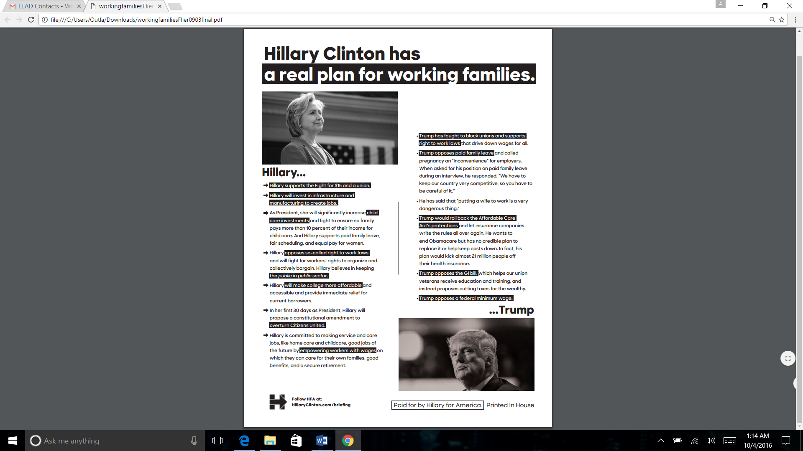

Robert Reich, is an American politician, academic, writer, and political commentator. He was named by Time Magazine as one of the ten most successful cabinet secretaries of the last century. In 2008 he served on President-elect Barack Obama's economic advisory board. A summa cum laude graduate of Dartmouth College, Reich is currently Chancellor's Professor of Public Policy at the Goldman School of Public Policy at the University of California, Berkeley.

**In regards to the most recent News on Donald Trump, From Robert Reich’s Facebook Page**:

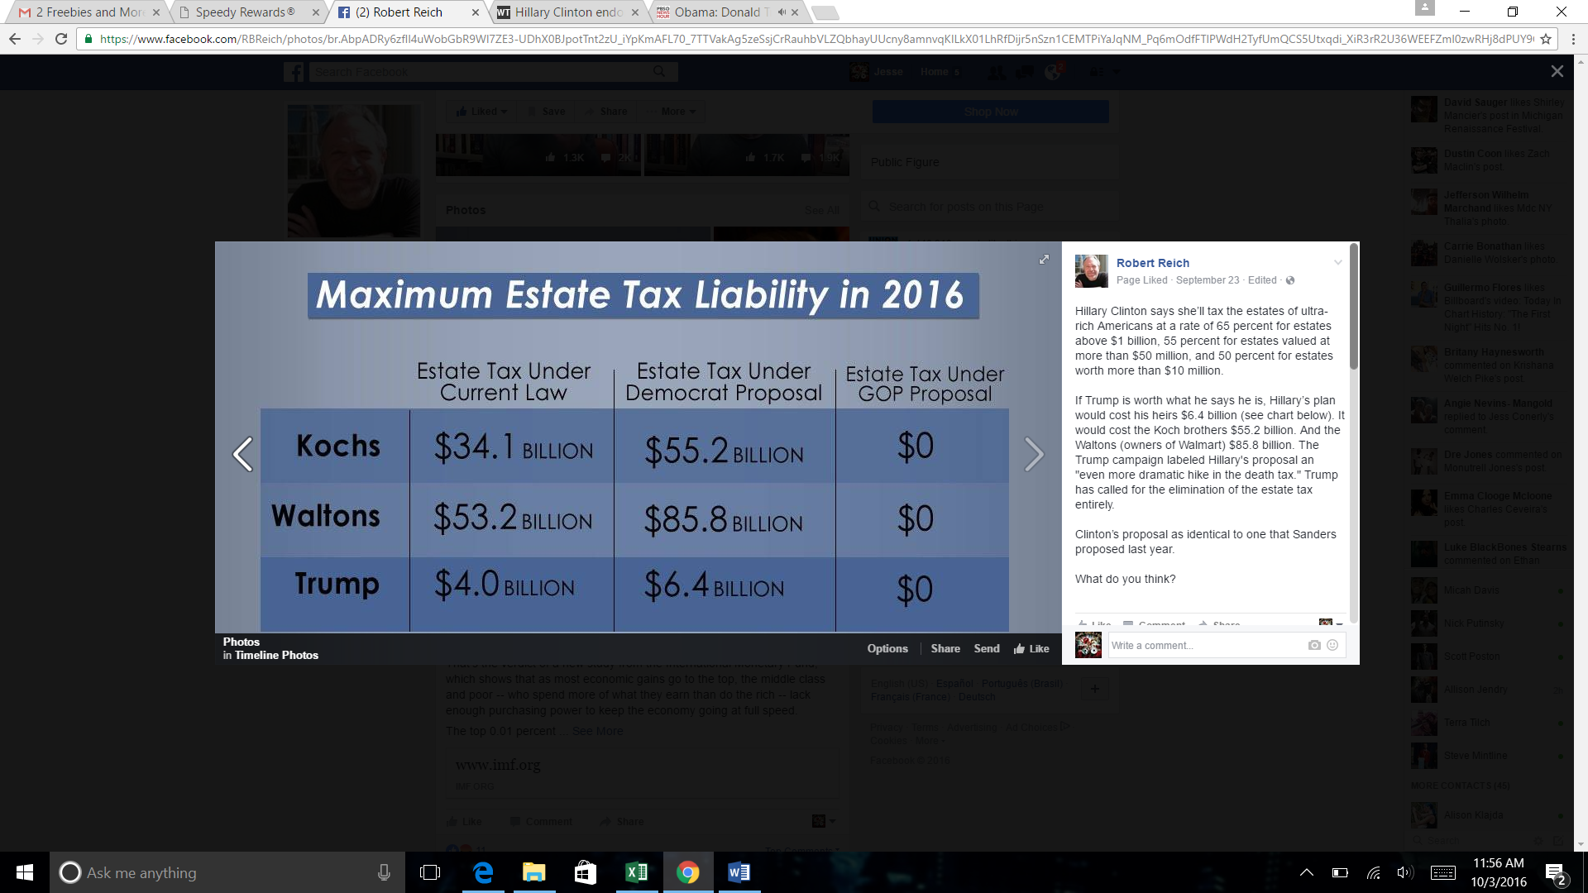“Donald Trump declared a $916 million loss on his 1995 tax returns -- which could have allowed him to legally avoid paying any federal income taxes for 18 years. That loss was from Trump's financial wreckage in the early 1990s. Ordinary investors in Trump’s business empire saw the value of their shares plunge to 17 cents from $35.50, bondholders got pennies on the dollar, and scores of contractors went unpaid. But Trump got a bonanza because the tax code allows “net operating losses” to cancel out taxable income in future years. Real estate losses are notoriously easy to create. Trump bought buildings with borrowed money. He could then deduct interest paid on that debt. On top of that, he could take depreciation deductions, even when his real estate was appreciating in value. Presto! He claims almost a billion dollars of losses that cancel his gigantic income gains.”

For a list of all the UAW endorsed candidates check out this website below (you can also register to vote AND get an absentee ballot: <https://uawendorsements.org/>

**This Information was Brought to you by the**

**UAW Local 14 Lead Mentor Team**

**Check out our Website for more Information and Other Topics:** <http://uawlocal14lead.wixsite.com/version1>