**Retirement, do you have a plan?**

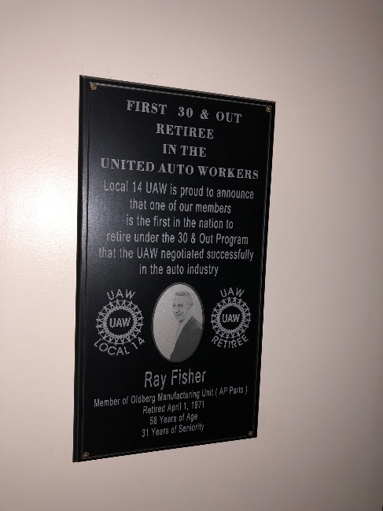  
This is the plaque in our union hall recognizing Ray Fisher as the first Auto worker in the nation to retire under the UAW 30 and out Program. We all want to achieve retirement! How we get there depends on what we do right now. Are you ready for your retirement?

**Classes Offered at the Union Hall**

* May 3rd **UAW Retiree Medical Benefit Trust class**. This will explain the VEBA. This is a must for any member that is about to retire, retirement healthcare is different than your current.
* May 4th **Fidelity Investments class** will position you for retirement one day. For all newer employees this is highly recommended. This class is also good for members that still have a few years left.
* May 8th is the **Social Security Benefits class** and is a must for members that are close to retirement or have around ten years to go. It goes into depth about retirement age how long you need to work to obtain a full pension with social security.

Spouses are welcomed to attend, if there are any questions please call Jerry Seager at (419) 470-5130