The Black Lake Conference Center has a rich history of not only the story of Walter Reuther, but also of labor’s part in shaping this nation. Originally the center was created as an educational center for the UAW members across the country. It was a meeting place of brotherhood where ideas could be taught, traded, shared and friendships built. By the completion of the Center, Reuther understood that this would be a place where families would build memories as well.

By January 1967, the UAW had purchased 1,000 heavily wooded acres along the shores of Black Lake. A skilled craftsman and tool and die maker by trade, Reuther envisioned the Center to be with nature. He wanted to bring the outdoors in and let the landscape dictate the Centers footprint on its environment. Reuther, along with longtime friend and renowned architect, Oskar Stonorov, were committed to preserving the oak, pines, maples, aspen and hemlock trees on the site. He and Sonorov wanted the Center to be a lesson on how to build without destroying nature. Reuther personally examined and tagged practically every tree on the site and, in some cases construction lines were altered to preserve a particular piece of nature.

In the early spring of 1970 Walter and May Reuther unveiled the Center’s main buildings for the UAW leadership, media and others. By May1970, the world mourned the death of a great leader and visionary when a plane carrying the Reuthers, Oskar Stonorov, Reuther’s bodyguard Willy Wolfman and two pilots crashed while on final approach to the Pellston Airport. All six passengers died in the crash.

Most trees on the grounds were planted after World War I or by the Civilian Conservation Corps during the Great Depression and are red, white jack and Scotch pine. There are also massive beams and columns in the Center came from Portland, Oregon. The dining room holds the largest beam which is 72 feet and had to be carried on two rail cars. Washington State on equipment once used to turn the mast of wooden sailing ships. More than 15,000 tons of stone from Wisconsin were used in the buildings. The bronze work was cast in Italy, and the roofs are strong enough to hold five feet of snow.

A city utility system exists underground. Reuther, an environmentalist long before it was popular to be green designed the Center to ensure maximum protection of the environment. A water treatment plant covers 6 acres including five, 1 acre lagoons which pump all waste water away from the lake, virtually eliminating pollution. Most of the Centers pipes and power lines are buried underground, leaving the pristine view untouched by power lines.

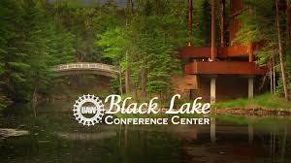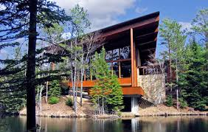

Black lake is a special place for the UAW and its members. It is a privilege to be able to attend a week long training program at the premier union training site. Many different training programs take place throughout the year at Black Lake. Each standing committee has a week dedicated to their specific issues and training needs every year. In addition to that each region of the UAW also has a week dedicated to their leadership training. Joint training classes for the big three are also scheduled at Black Lake for periodical needs. It would be nice if every member had an opportunity to attend Black Lake at least once in their career. Local unions normally send people that are involved in the union and are a part of standing committees or are elected officials. We want to reward involvement, we also want to make opportunities available for members that haven’t experienced Black Lake for the first time. Because of this we would like you to canvass your mentees and see who **has not** attended Black Lake yet. We will gather these individuals’ names and have a drawing for at least one member to attend the next Region 2B Leadership Training at Black Lake. Please make sure they are willing to go. Lost time will be paid per the Bylaws along with traveling expenses. For mentors that have not been to Black Lake we would like for you to let us know that as well.