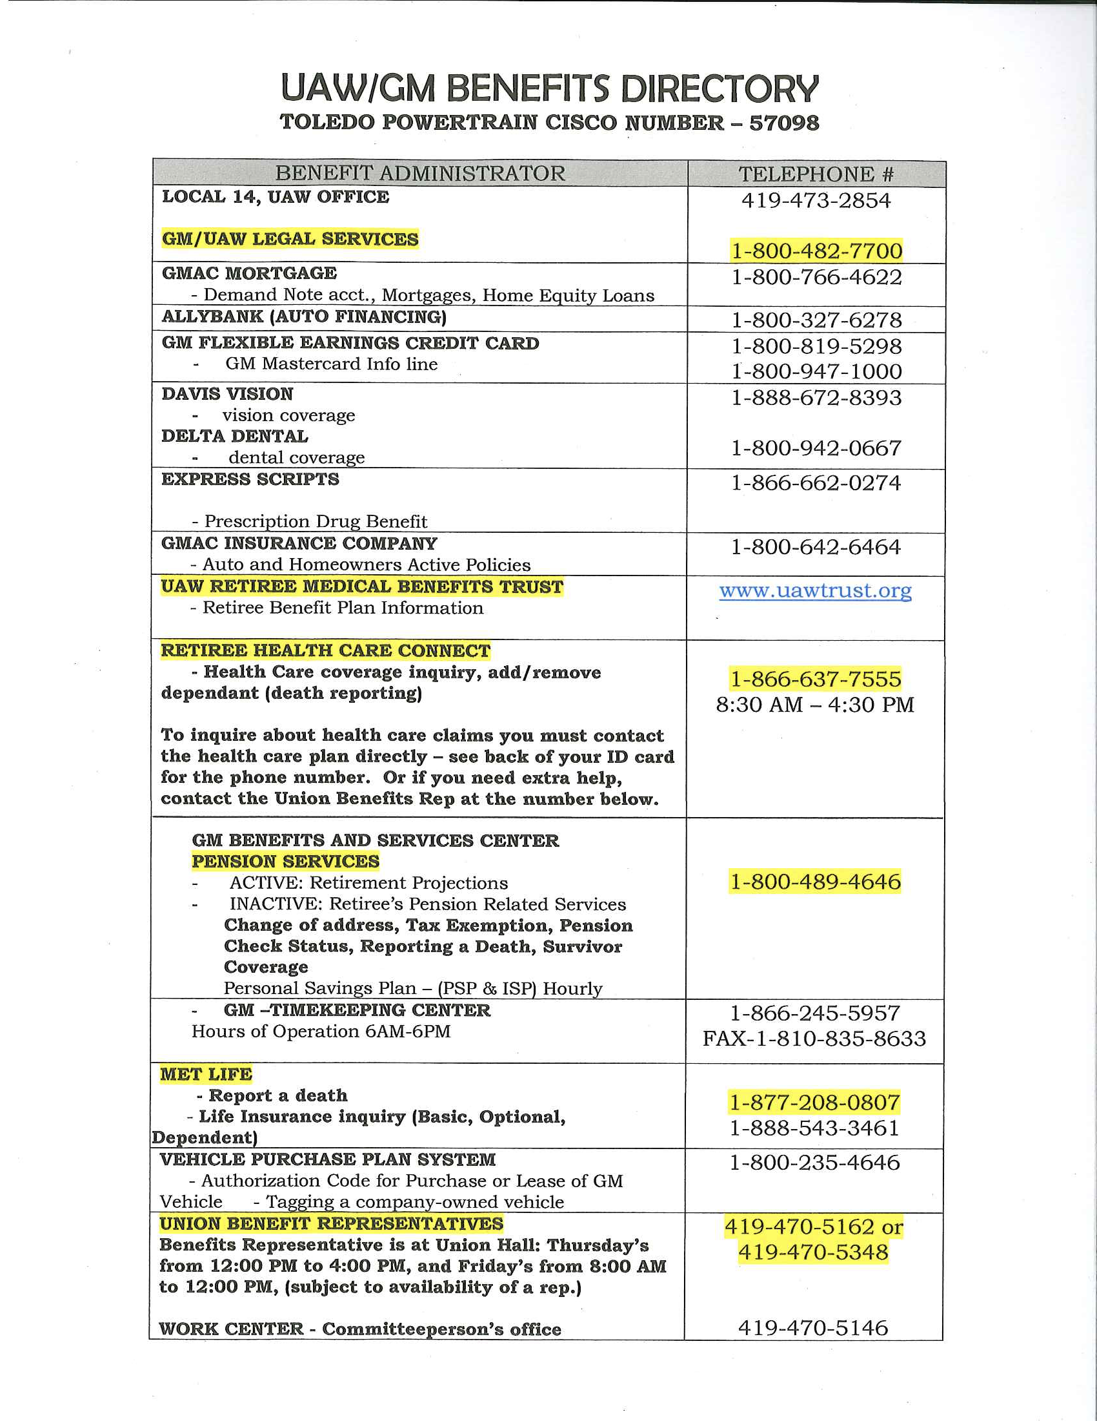

**Alphabetical Important Phone Numbers**

**Absentee Call-In 1-800-222-8889**

**ADAPT / Placement 419-470-5150**

**Benefits 419-470-5162 / 5348**

**Communications 419-902-6656**

**EAP Work Family 419-470-5130**

**Emergency Call-In 419-470-5452**

**Glass City Federal Credit Union 419-476-1791**

**GM National Benefit Center 1-800-489-4646**

**TTY Service for Hearing or Speech Impaired: 1-877-347-5225**

* **GM Health Care**
* **Pension Administration**

**GM/UAW Legal Services 1-800-482-7700**

**Hourly Personnel 419-470-5640**

**Local 14 UAW President 419-473-2854**

**Local 14 Union Hall 419-473-2854**

**Plant Medical 419-470-5133 / 5134**

**Oscar Bunch / GM TTO Family Park 419-470-5166**

**Shop Chairman 419-470-6999**

**Work Center 419-470-5489 (In Plant)**

**Work Center Outside Line 419-470-5146 / 5489**

**National Managed Pharmacy Program for GM Enrollees 1-800-464-4679**

**Express Scripts 1-800-282-2881**

**Express Scripts TTY (Hearing Impaired) 1-800-759-1089**

**Vehicle Purchase Plan System 1-800-489-4646**

