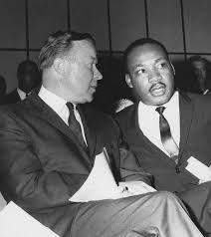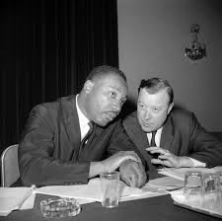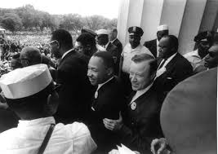

This January 15th we will be celebrating the Martin Luther King Jr. Holiday. This is a federal Holiday that many Americans have as a paid holiday from their employers. Not everyone knows the role the UAW played in supporting the civil rights movement and the holiday. UAW President Walter Reuther was an avid supporter of civil rights at a time when people didn’t always speak out in support.  Reuther was later a friend of Martin Luther King, Jr. and the UAW supported the movement in many ways, including paying bail and court costs for those arrested for the cause.

* Walter Reuther believed unionism was not confined simply to improving life at the workplace. He viewed the role of the union as a social movement aimed at uplifting the community within the guarantees of democratic values.
* The night before his assassinationin April 1968, Martin Luther King told a group of striking sanitation workers in Memphis, Tennessee: “We’ve got to give ourselves to this struggle until the end.  Nothing would be more tragic than to stop at this point in Memphis. We’ve got to see it through”
* Walter Reuther worked tirelessly, and stood shoulder to shoulder with Dr. King and the other organizers at the March on Washington.  The full name was: **The March on Washington for Jobs and Freedom.**
* They both stood for worker and human rights while bonding a legacy of justice through activism.

“I am here today with you because, with you, I share the view that the struggle for civil rights and the struggle for equal opportunity is not the struggle of Negro Americans, but the struggle for every American to join in.”

Walter Ruether

2018 UAW Negotiated Paid Holiday’s

January 15th Martin Luther King Jr.

March 30th Good Friday

April 2nd Day after Easter

May 28th Memorial Day

July 4th Independence Day

September 3rd Labor Day

November 6th Federal Election Day

November 12th Veterans Day

November 22nd Thanksgiving

November 23rd Day after Thanksgiving

December 24th  Christmas Holiday period

December 25th Christmas Holiday period

December 26th Christmas Holiday period

December 27th Christmas Holiday period

December 28th Christmas Holiday period

December 29th Christmas Holiday period

December 31st Christmas Holiday period

January 1st 2019 New Year’s Day